**Machine Learning in R**

Machine learning is a branch in computer science that studies the design of algorithms that can learn. Typical machine learning tasks are concept learning, function learning or “predictive modeling”, clustering and finding predictive patterns.

### Built-in Datasets of R

This tutorial uses the Iris data set, which is very well-known in the area of machine learning. This dataset is built into R, so you can take a look at this dataset by typing the following into your console:

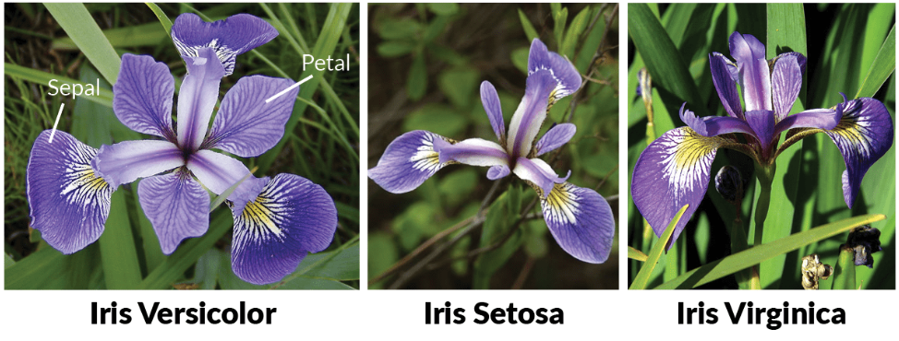

# Read in `iris` data

iris <- read.csv(url("http://archive.ics.uci.edu/ml/machine-learning-databases/iris/iris.data"),

header = FALSE)

# Print first lines

head(iris)

# Add column names

names(iris) <- c("Sepal.Length", "Sepal.Width", "Petal.Length", "Petal.Width", "Species")

# Check the result

iris

